TAU LABS

NUMBER_1

#1

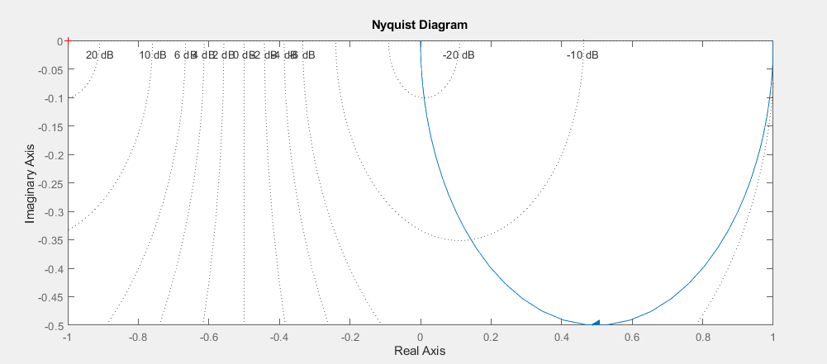

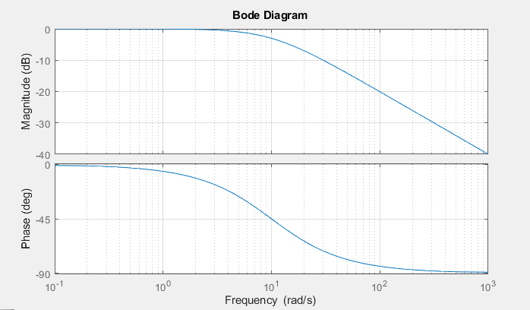

#2

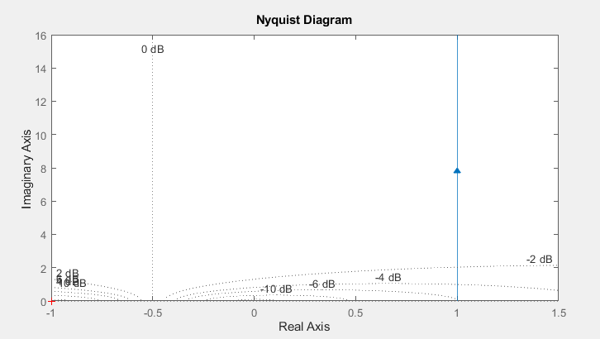

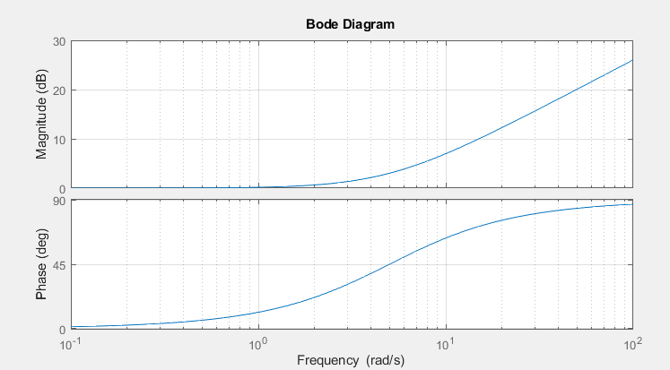

#3

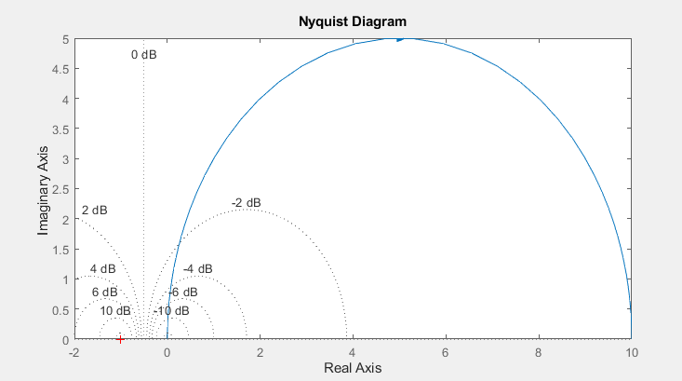

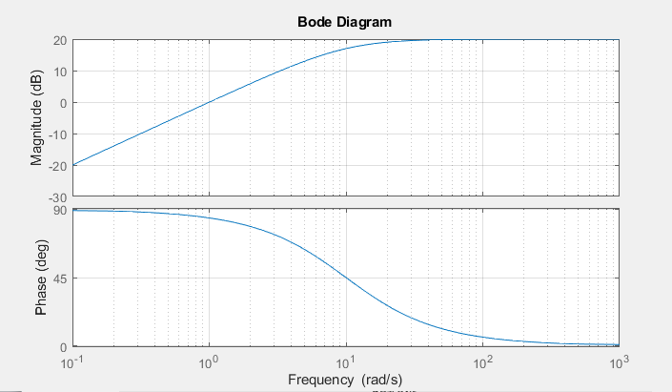

#4

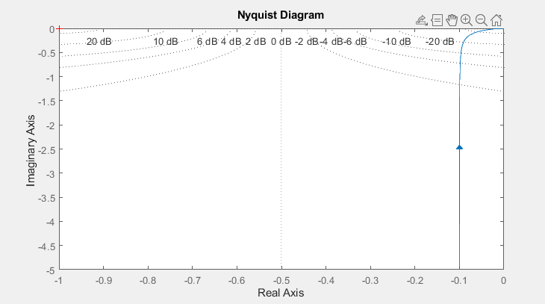

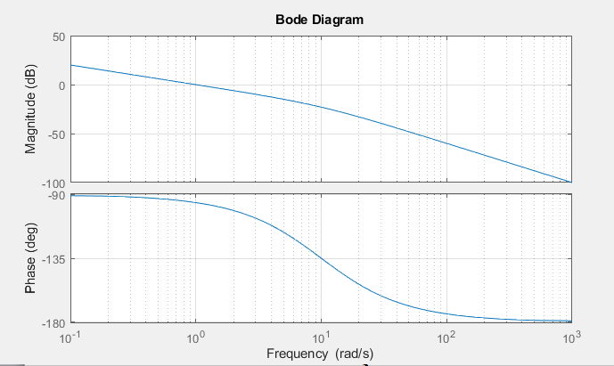

#5

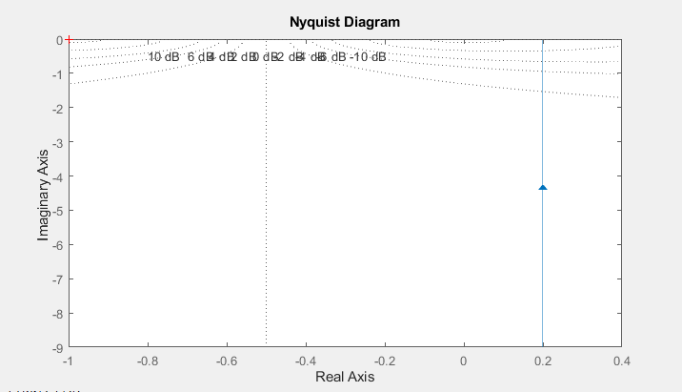

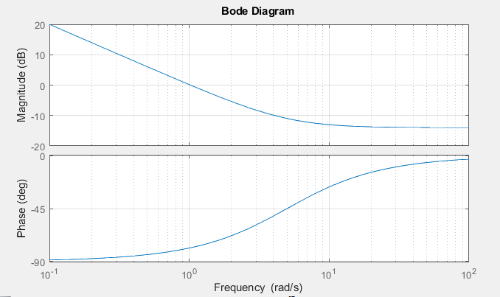

#6

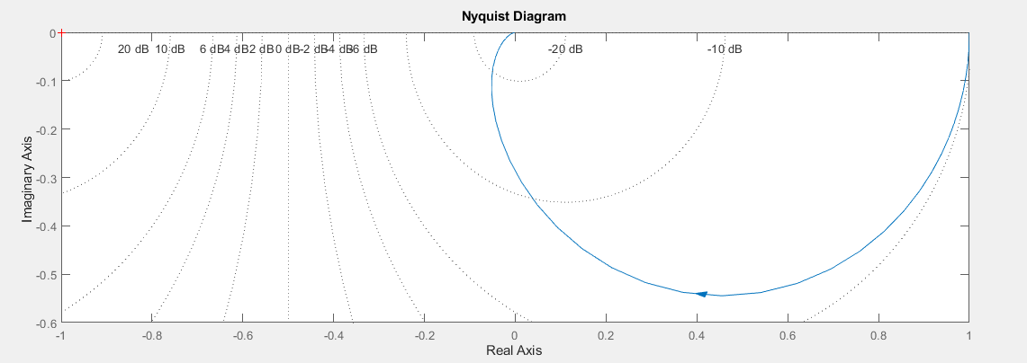

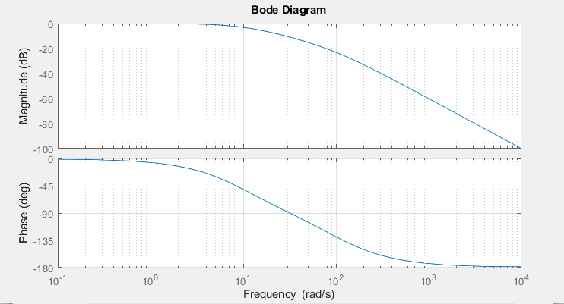

#7

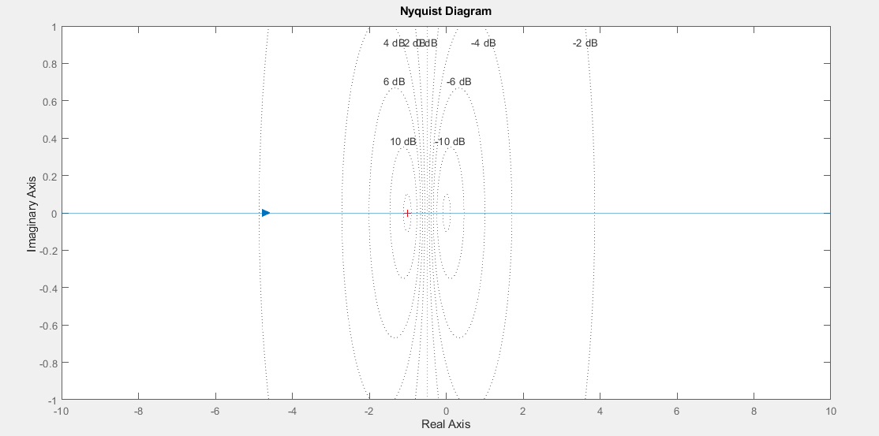

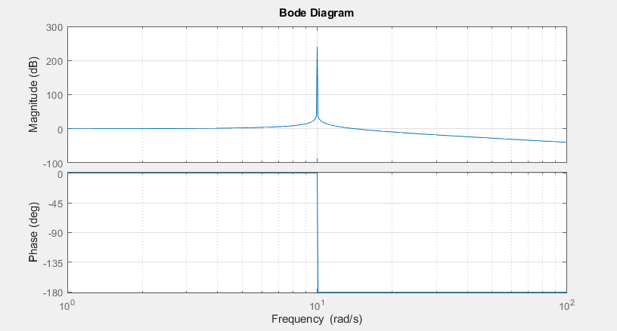

#8

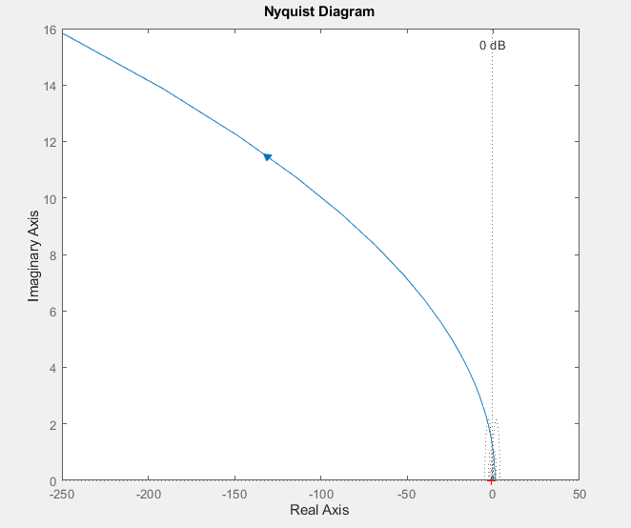

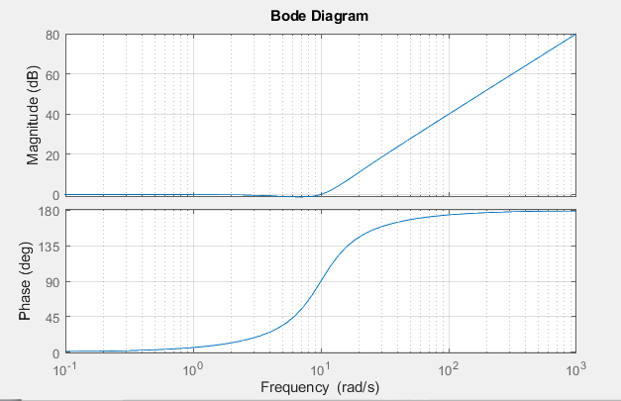

>> WF1=tf([1],[0.1 1]);

>> figure(1)

>> nyguist(WF1)

Unrecognized function or variable 'nyguist'.

Did you mean:

>> nyquist(WF1)

>> figure(2)

>> bode(WF1)

>> WID=tf([0.2 1],[1]);

>> figure(3)

>> nyquist(WID)

>> figure(4)

>> bode(WID)

>> WTF=tf([1 0],[0.1 1]);

>> figure(5)

>> nyquist(WTF)

>> figure(6)

>> bode(WTF)

>> WFF=tf([1],[0.1 1 0]);

>> figure(7)

>> nyquist(WFF)

>> figure(8)

>> bode(WFF)

>> WAF=tf([0.2 1],[1 0]);

>> figure(9)

>> nyquist(WAF)

>> figure(10)

>> bode(WAF)

>> WEF=tf([1],[0.001 0.11 1]);

>> figure(11)

>> nyquist(WEF)

>> figure(12)

>> bode(WEF)

>> syms AE;

>> collect((0.01*AE+1)*(0.1*AE+1))

ans =

AE^2/1000 + (11*AE)/100 + 1

>> SBER=tf([1],[0.01 0 1]);

>> figure(13)

>> nyquist(SBER)

>> figure(14)

>> bode(SBER)

>> SAF=tf([0.01 0.1 1],[1]);

>> figure(15)

>> nyquist(SAF)

>> figure(16)

>> bode(SAF)

NUMBER_2

#1

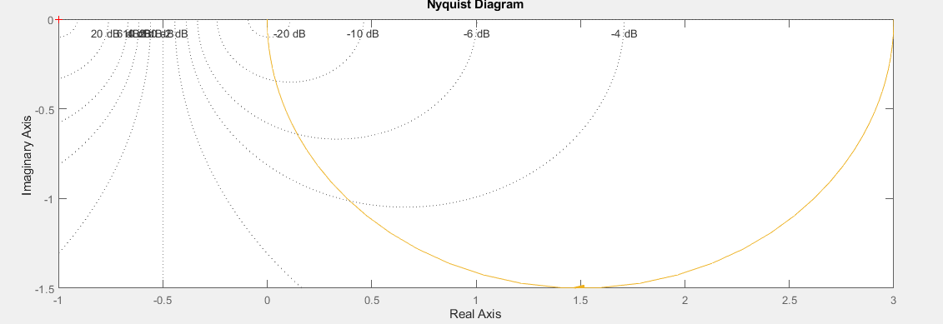

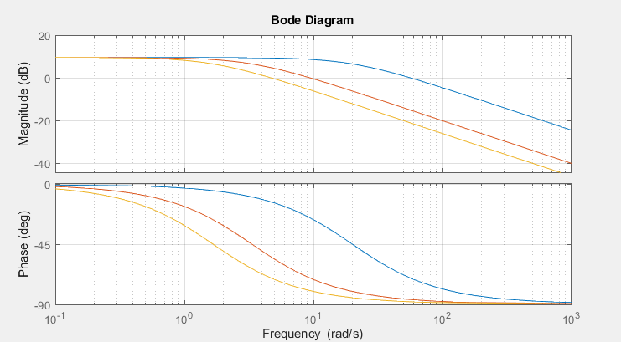

#2

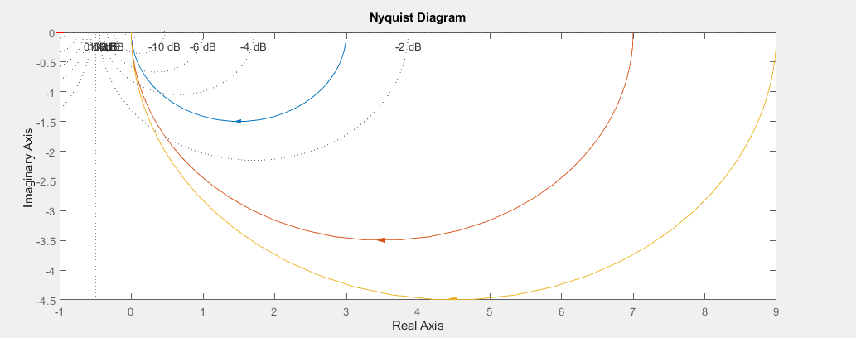

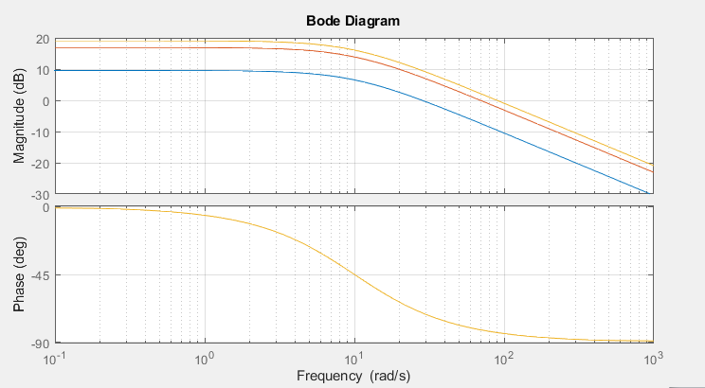

DAG1=tf([3],[0.05 1]);

>> DAG2=tf([3],[0.3 1]);

>> DAG3=tf([3],[0.6 1]);

>> figure(17)

>> nyquist(DAG1,DAG2,DAG3)

>> figure(18)

>> bode(DAG1,DAG2,DAG3)

>> GAD1=tf([3],[0.1 1]);

>> GAD2=tf([7],[0.1 1]);

>> GAD3=tf([9],[0.1 1]);

>> figure(19)

>> nyquist(GAD1,GAD2,GAD3)

>> figure(20)

>> bode(GAD1,GAD2,GAD3)

>>

NUMBER_3

A

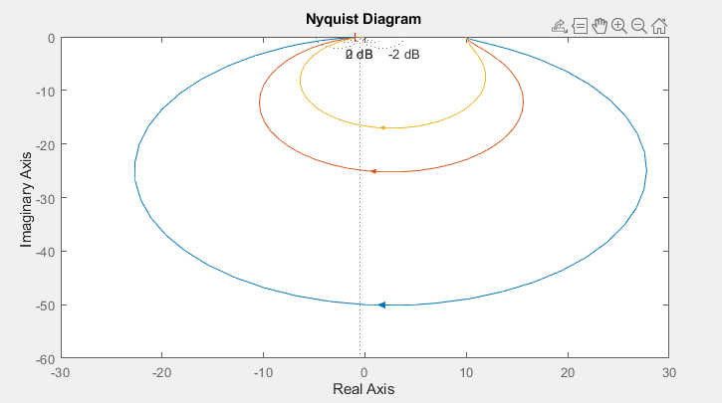

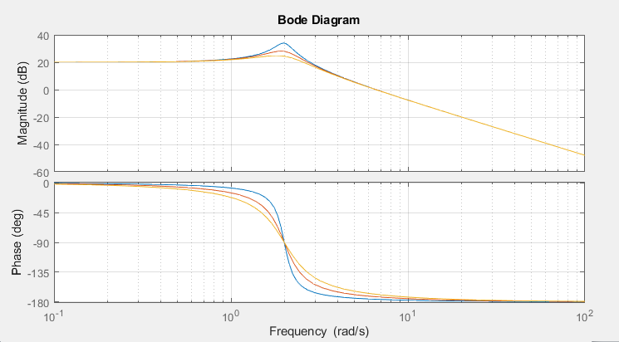

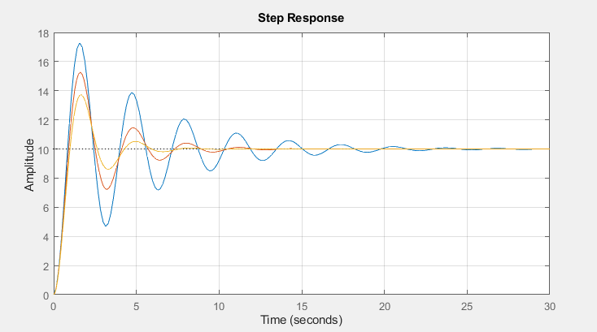

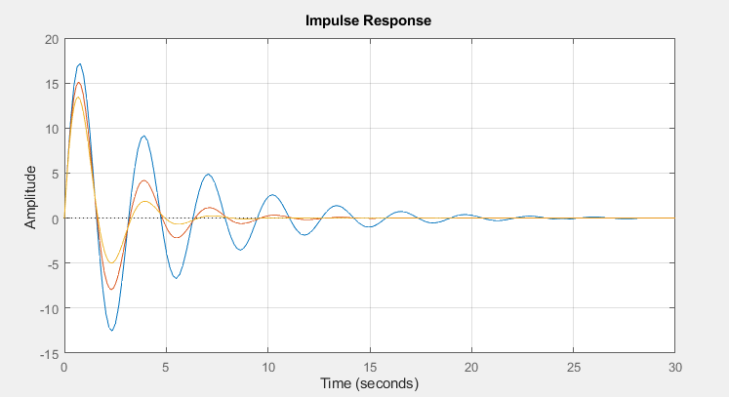

B

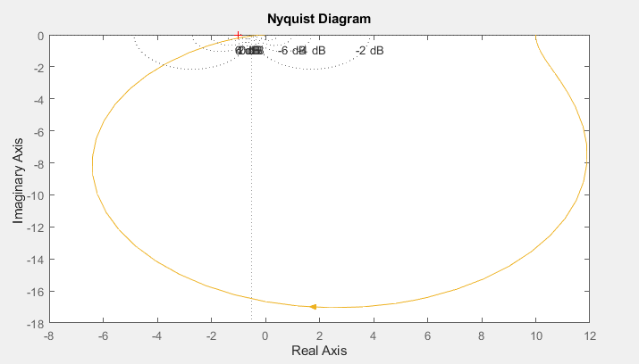

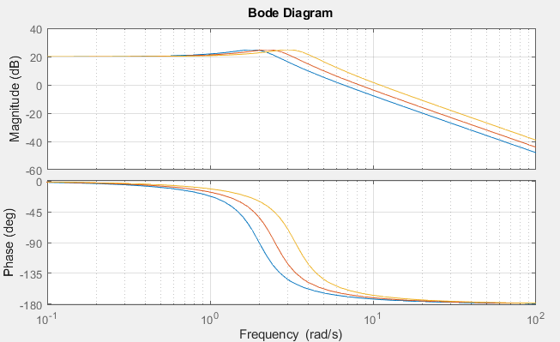

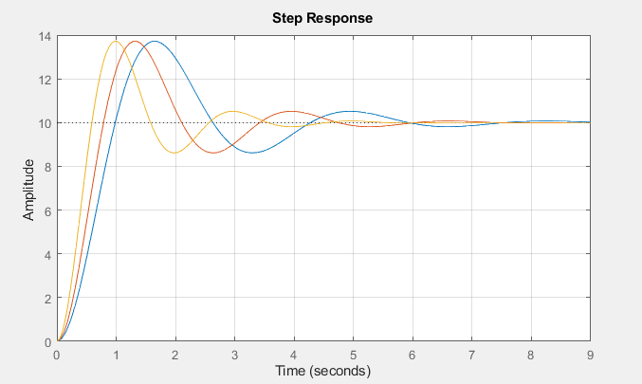

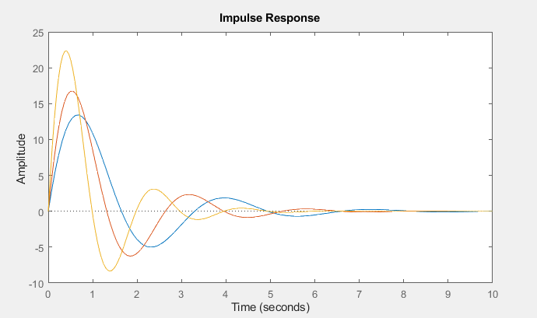

C

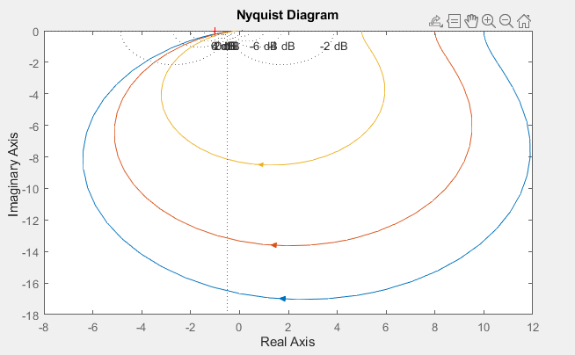

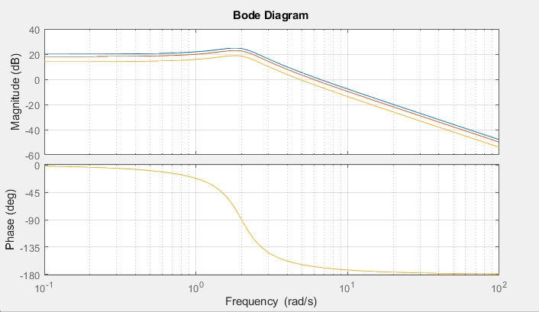

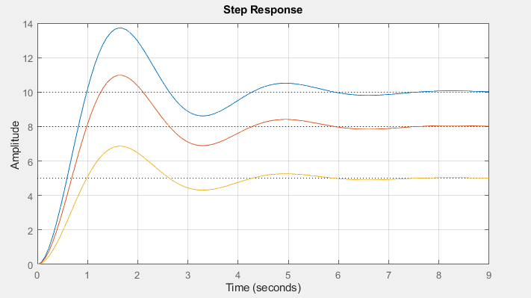

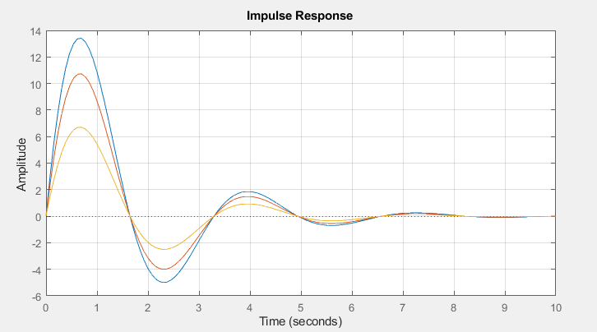

WKA1=tf([10],[0.5^2 2*0.1*0.5 1]);

>> WKA2=tf([10],[0.5^2 2*0.2*0.5 1]);

>> WKA3=tf([10],[0.5^2 2*0.3*0.5 1]);

>> figure(21)

>> nyquist(WKA1,WKA2,WKA3)

>> figure(22)

>> bode(WKA1,WKA2,WKA3)

>> figure(23)

>> step(WKA1,WKA2,WKA3)

>> figure(24)

>> impulse(WKA1,WKA2,WKA3)

>> WKB1=tf([10],[0.5^2 2*0.3*0.5 1]);

>> WKB2=tf([10],[0.4^2 2*0.3*0.4 1]);

>> WKB3=tf([10],[0.3^2 2*0.3*0.3 1]);

>> figure(25)

>> nyquist(WKB1,WKB2,WKB3)

>> figure(26)

>> bode(WKB1,WKB2,WKB3)

>> figure(27)

>> step(WKB1,WKB2,WKB3)

>> figure(28)

>> impulse(WKB1,WKB2,WKB3)

>> WKG1=tf([10],[0.5^2 2*0.3*0.5 1]);

>> WKG2=tf([8],[0.5^2 2*0.3*0.5 1]);

>> WKG3=tf([5],[0.5^2 2*0.3*0.5 1]);

>> figure(29)

>> nyquist(WKG1,WKG2,WKG3)

>> figure(30)

>> bode(WKG1,WKG2,WKG3)

>> figure(31)

>> step(WKG1,WKG2,WKG3)

>> figure(32)

>> impulse(WKG1,WKG2,WKG3)

>> figure(29)

>> nyquist(WKG1,WKG2,WKG3)

>> figure(28)

>> impulse(WKB1,WKB2,WKB3)